1. **Abstract:**

The purpose of the project entitled as “HOSPITAL MANAGEMENT – ONE TOUCH SOLUTION” is to computerize the Front Office Management of Hospital. It deals with the collection of patient’s information, diagnosis details. The main function of the system is register and store patient details and retrieve these details as and when required.

1. **Project Plan**

**PERT**

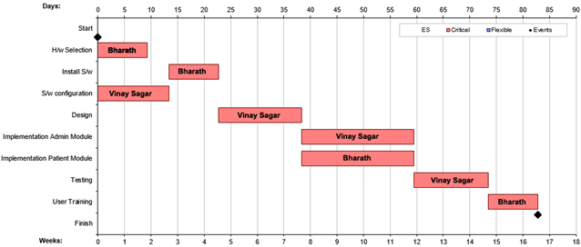

1. **Introduction:**
   1. **Objective:**

* The objective is to develop mobile application for hospitals.
* Eliminating the paper work and file handling work of the hospitals.
  1. **Existing System:**
* The current system is manual where data is written on different papers
* Patient files are shared among different departments
* Human errors are common in existing system, since it is paper based work.
* Retrieval of files was time consuming as they had to manually locate files some of which were even lost and thus finding such information was hard.
  1. **Proposed System:**
* The proposed system is to develop mobile application that maintains a centralized repository of all patient related information.
* Patient information can be accessed at any time without having to find the physical files and diagnosis papers.
  1. **Problem Statements:**

The absence of a well-established information system to serve patient has led to inconveniences. This is because of the weakness of the existing system that is, reliance on paper based work. Paper files consume a lot of the office space, slow recording, processing and retrieval of patient details. Accessing and sharing of information by different departments is difficult due to poor information management.

1. **Software Requirement Specification**
   1. **Introduction**

This software requirements specifications document is prepared by following the IEEE SRS format categorized by Users. [1]

* + 1. **Purpose:**

The purpose of the project is to develop a system that automates the process of storing patient details and diagnosis details and retrieve these details as and when required.

* + 1. **Scope**

The scope is limited to hospitals which are tied up with Sensesemi Technologies Private Ltd

* + 1. **Definition, Acronym and Abbreviation**

|  |  |
| --- | --- |
| **Abbreviation** | **Full Form** |
| Admin | administrator |

* + 1. **Overview**

SRS contains the overall description of the system; it states the general factors that affect the product and its requirements, specific requirements and defining the constraints on the system. This project is used by hospitals. Hospital registers itself with our service. Hospital enters the users details and diagnosis details. Hospital can retrieve these details as and when required.

* 1. **Overall Description:**
     1. **Product Perspective:**

Hospital can register to Sensesemi services and can store the patient and diagnosis details.

* + - 1. **User interfaces**
* For hospitals to get registered with Sensesemi service, the hospital has to fill the details such as hospital name, email, phone number, password etc.
* Once it is done an OTP is sent to registered mobile. Hospital has to enter the valid OTP to get registered.
* After registering, hospital can enter the patient details and diagnosis details. It is stored in database.
* They can query for particular patient id to get that particular patient details.
  + - 1. **Hardware Interface:**

**Minimum hardware requirement for development**

* Android Mobile with Minimum SDK level of 17.
* RAM: 1 GB.
* Screen resolution of at least 1080x1920 pixels required for proper and complete viewing of screens

**Minimum hardware requirement for deployment**

* Android Mobile with Minimum SDK level of 17.
* Minimum SDK level of 17.
* RAM: 1 GB.
* Screen resolution of at least 1080x1920 pixels required for proper and complete viewing of screens
  + - 1. **Software Interface:**

**Minimum software requirements for development**

* IDE : Android Studio 2.3
* Front end development language: XML, JAVA
* Back end : Google Cloud SQL  5.7

**Minimum software requirements for deployment**

* Front end development language: XML, JAVA
* Back end : Google Cloud SQL  5.7
  + - 1. **Communication interfaces**

The communication between the mobile device and cloud database is through API.

* + 1. **Functional Requirements:**
* The system allows the hospital to register.
* Hospital can add and view the patient and diagnosis details.
  + 1. **Performance requirements**
* Non Functional requirements involve checking the operation of the system by giving certain data inputs(username and password)
* The software will be available all the time for its use and will be working flawlessly without any issues from its end.
* As the software is portable there is no issue of accessibility as long as the user has proper credentials.

1. **Design**

**Administrator**

|  |  |  |  |
| --- | --- | --- | --- |
| Attribute | Data Type | Size | Constraints |
| Id | Int | 11 | Primary Key |
| username | text |  | Not Null |
| password | text |  | Not Null |

**Hospital**

|  |  |  |  |
| --- | --- | --- | --- |
| Attribute | Data Type | Size | Constraints |
| Id | Int | 11 | Primary Key |
| username | text |  | Not Null |
| password | text |  | Not Null |
| Name | Text |  | Not Null |
| Phone | Text |  | Not Null |
| Address | Text |  | Not Null |
| Pin | Text |  | Not Null |
| City | Text |  | Not Null |
| Country | Text |  | Not Null |
| Specialization | Text |  | Not Null |
| Reg. Number | Text |  | Not Null |

**5.2 Use Case Diagram**

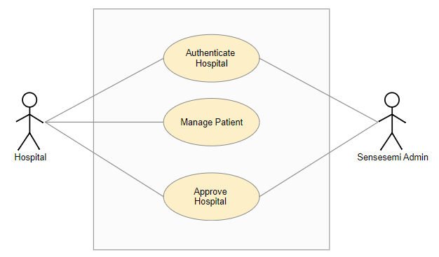

**Figure 1**

**5.3 Class Diagram**

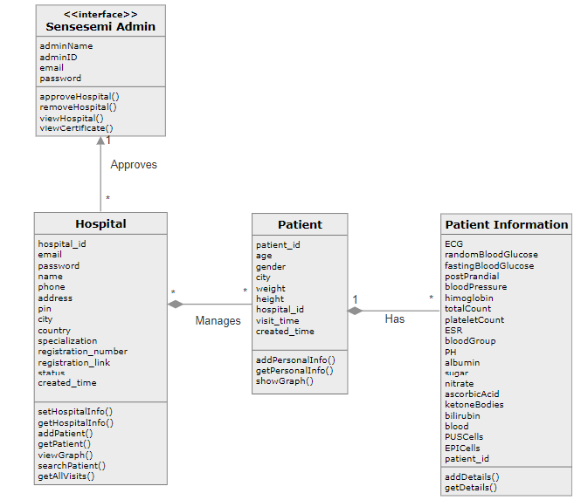

**Figure 2**

**5.4 Sequence Diagram**

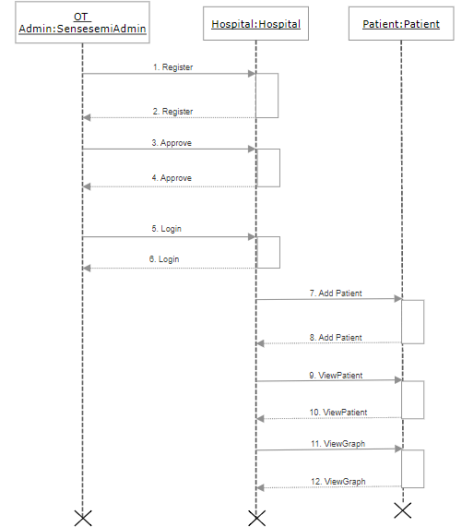

**Figure 3**

**6. Implementation**

**6.1 Technology used**

**Android**

The Android operating system (OS) is based on the Linux kernel. Unlike Apple's iOS, Android is open source, meaning developers can modify and customize the OS for each phone. Therefore, different Android-based phones often have different graphical user interfaces GUIs even though they use the same OS. Android phones typically come with several built-in applications and also support third-party programs. Developers can create programs for Android using the free Android software developer kit (SDK). Android programs are written in Java and run through a Java virtual machine JVM that is optimized for mobile devices. The "Dalvik" JVM was used through Android 4.4 and was replaced by Android Runtime or "ART" in Android 5.0. Users can download and install Android apps from Google Play and other locations [2].

# Google Cloud

Google Cloud Platform is a suite of public cloud computing services offered by Google. The platform includes a range of hosted services for compute, storage and application development that run on Google hardware. Google Cloud Platform services can be accessed by software developers, cloud administrator and other enterprise IT professionals over the public internet or through a dedicated network connection [3].

**6.2 Pseudo code**

**Step1:** Go to Sensesemi application on your mobile.

**Step2:** Click on Hospital.

**Step3:** Enter username and password. Wait till Administrator approves your account.

**Step4**: On administrator login we can display the number of records pending accounts that needs to be approved by administrator.

**Step5**: Login to your account.

**Step6**: Click on Add Patient and enter all the details and click save.

**Step7:** Click on search patient. Give valid patient id and click on search.

**Step8:** Click on view graph button to view the health graph.

**7 Testing**

Testing is the process of evaluating a system or its component with the intent to find whether a system satisfies the specified requirements or not. Testing is executing a system in order to identify any gaps, errors, or missing requirements in contrary to the actual requirements.

**7.1 Unit testing**

Unit testing is a level of software testing where individual unit/components of software are tested. The purpose is to validate that each unit of the software performs as expected to work

* The module authenticated login for hospital and user is successfully passed.
* The module uploading by user is successfully passed.
* The module get the information and view successfully passed

**7.2 Regression testing**

#### Regression testing is in which the given app should work in all screen it must be adaptive.

* The module has been checked with other device and its successfully passed.
* The module even got checked with the different screen size and successfully passed
  1. **Validation Testing**
* Validation testing ensures that the authenticated user accesses the system entering valid details.
* All the input fields are tested and are working according to specified validations.

|  |  |
| --- | --- |
|  | **7.4 Test Cases** |

|  |  |  |  |  |  |  |  |  |  |  |  |  |  |  |  |  |  |  |  |  |  |  |  |  |  |  |  |  |  |  |  |  |  |  |  |  |  |  |  |  |  |  |  |  |  |  |  |  |  |  |  |  |  |  |  |  |  |  |  |  |  |  |  |  |  |  |  |  |  |  |  |  |  |
| --- | --- | --- | --- | --- | --- | --- | --- | --- | --- | --- | --- | --- | --- | --- | --- | --- | --- | --- | --- | --- | --- | --- | --- | --- | --- | --- | --- | --- | --- | --- | --- | --- | --- | --- | --- | --- | --- | --- | --- | --- | --- | --- | --- | --- | --- | --- | --- | --- | --- | --- | --- | --- | --- | --- | --- | --- | --- | --- | --- | --- | --- | --- | --- | --- | --- | --- | --- | --- | --- | --- | --- | --- | --- |
| **7.4.1 For Hospital**   |  |  |  |  |  |  | | --- | --- | --- | --- | --- | --- | | **Test Case Id** | **Test Case**  **Description** | **Excepted Results** | **Observed Results** | **Actual Results** | **Pass/Fail** | | OT-1 | Start the server(always online) | Server started | Server started | Server started | Pass | | OT-2 | **V**alidate hospital login  Username:administrator  Password:administrator | Login **s**uccessful | Login **s**uccessful | Login **s**uccessful | Pass | | OT-3 | Woking on all screen size | Successfully working | Successfully working | Successfully working | Pass | | OT-4 | Add Patient | Successfully Added | Successfully  Added | Successfully Added | Pass | | OT-5 | View patient details and graph | Successfully  Viewed | Successfully  Viewed | Successfully  Viewed | Pass | | OT-4 | Administrator logout | Logout Success | Logout  Success | Logout  Success | Pass |   **7.4.2 For Administrator**   |  |  |  |  |  |  | | --- | --- | --- | --- | --- | --- | | **Test Case Id** | **Test Case**  **Description** | **Excepted Results** | **Observed Results** | **Actual Results** | **Pass/Fail** | | OT-1 | Start the server(always online) | Server started | Server started | Server started | Pass | | OT-2 | **V**alidate hospital login  Username:administrator  Password:administrator | Login **s**uccessful | Login **s**uccessful | Login **s**uccessful | Pass | | OT-3 | Administrator hospital approve | Successfully Approved | Successfully  Approved | Successfully Approved | Pass | | OT-4 | Administrator logout | Logout Success | Logout  Success | Logout  Success | Pass |     **8** **Conclusion :**  One touch solution is an Android application which is online information storage.   * One touch solution eliminates the maintaining physical copies of the patient’s records in that case we are reducing the manual entry. * One touch solution keeps all the details safe and secure so the we can use the data of the patients   **9** **Future Enhancement :**   * Giving login even for patients so that they can view their health graph. * IOS version of application   **10 Bibliography**   1. https://ieeexplore.ieee.org/document/278253 2. <https://techterms.com/definition/android> 3. <https://searchcloudcomputing.techtarget.com/definition/Google-Cloud-Platform> 4. <https://firebase.google.com/support/release-notes/android> 5. <https://cloud.google.com/support-hub/> 6. <https://httpd.apache.org/> 7. <https://www.getpostman.com/> |  |

**Screenshots**

Hospital Signup(Hospital Details) 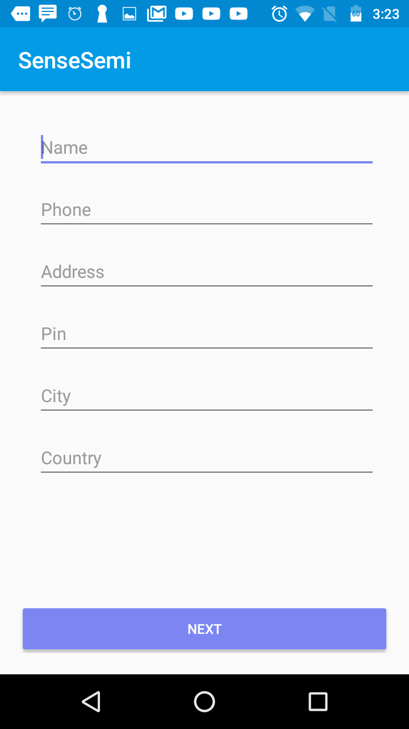

*Figure 10*

Once hospital is registered, it has to fill the above details.

Hospital Signup 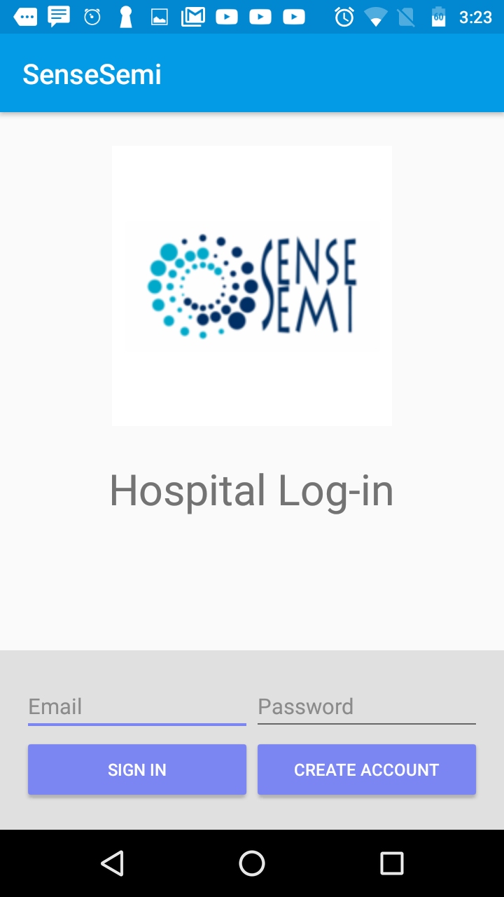

*Figure 9*

Hospital will register with the Sensesemi service by giving username and password.

Waiting for administrator approval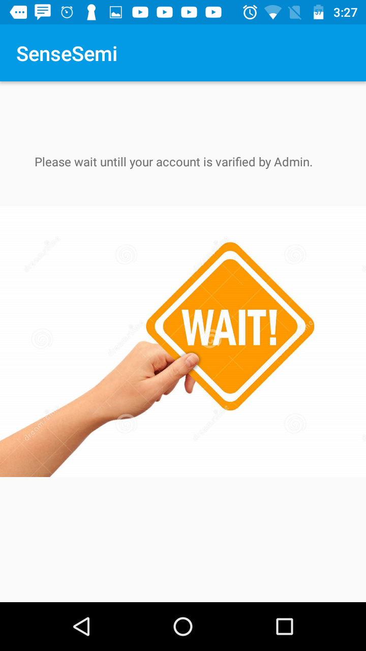

*Figure 12*

Once the registration is complete, it has to wait for administrator approval.

Hospital Signup(Hospital Details) 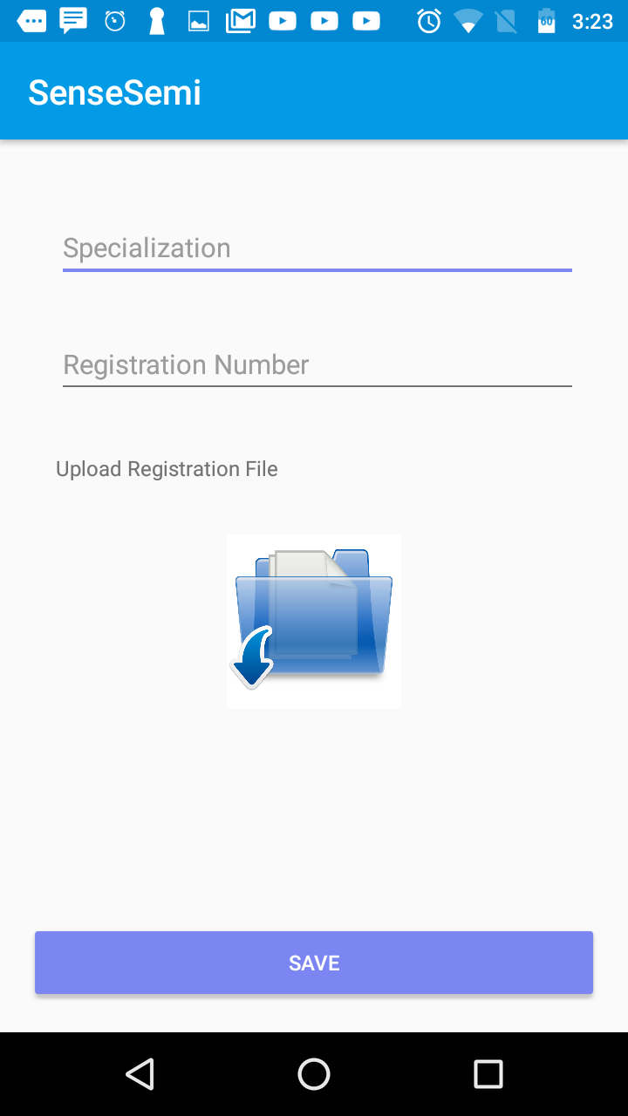

*Figure 11*

Once hospital is registered, it has to fill the above details.

Administrator login

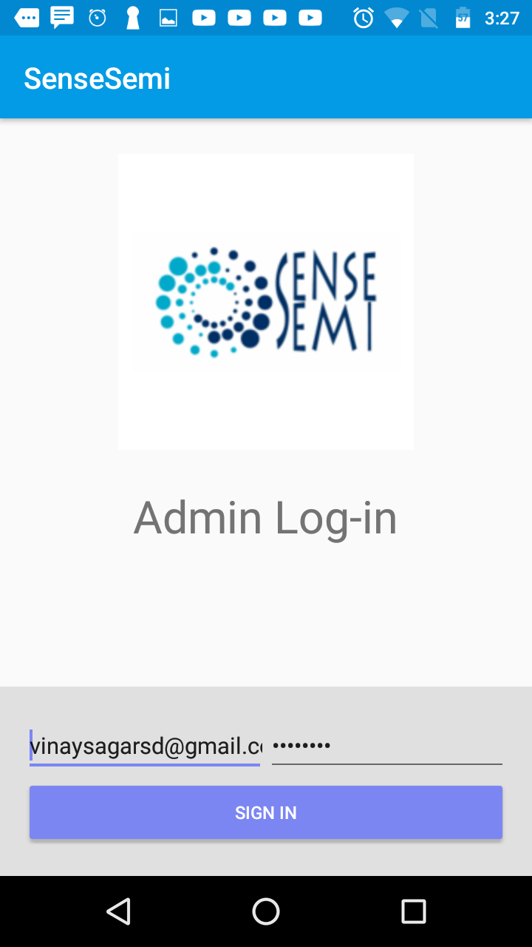

*Figure 13*

Sensesemi administrator should login by giving username and password.

Pending hospital list

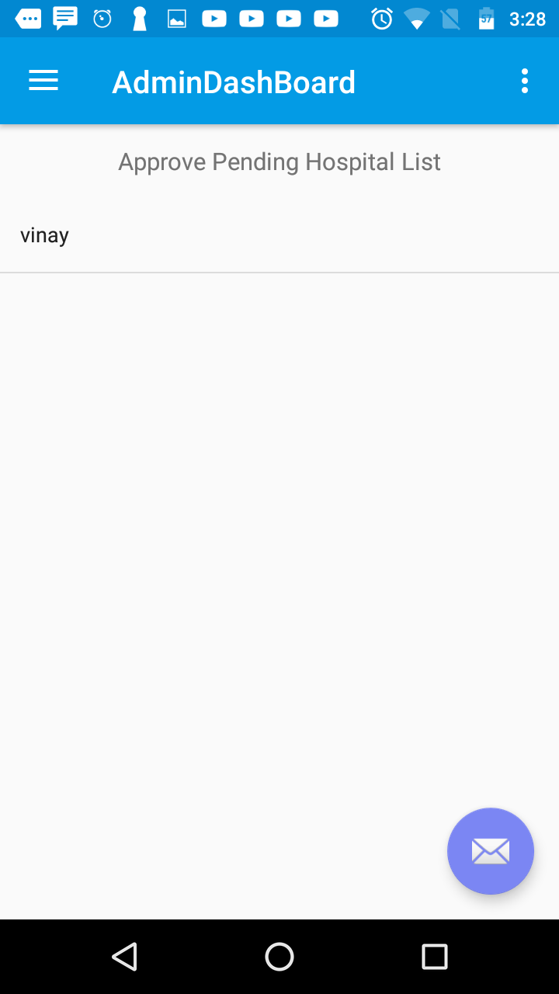

*Figure 14*

After administrator login, a list is shown with all the hospital waiting for approval.

Hospital Login



*Figure 16*

Hospital will login with username and password.

Verify document and approve

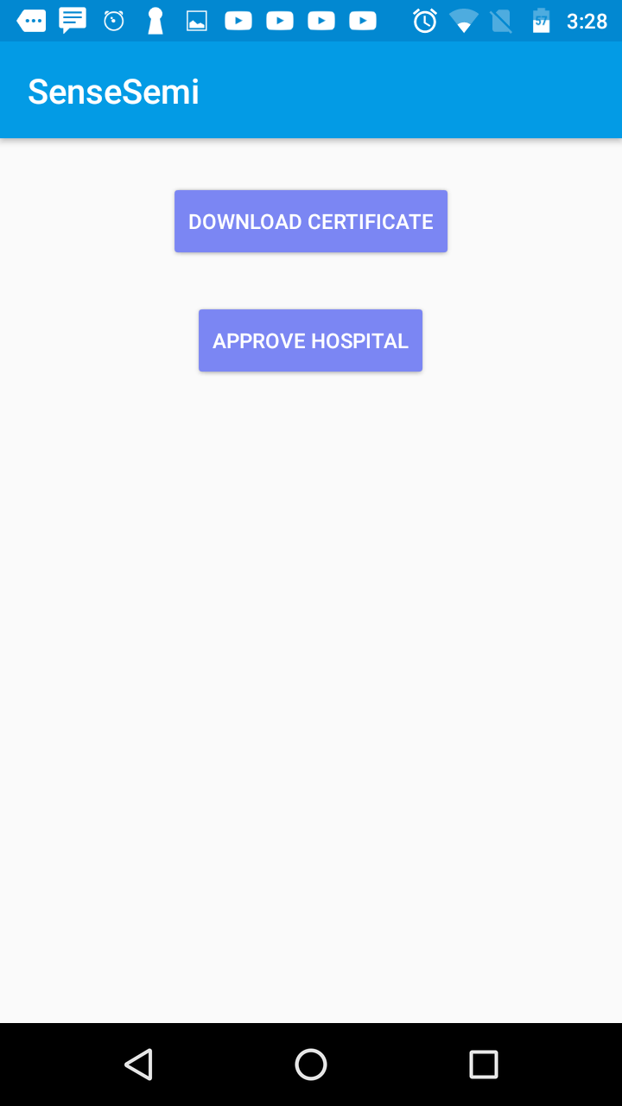

*Figure 15*

Administrator can download the registration document and approve the hospital.

Hospital Dashboard 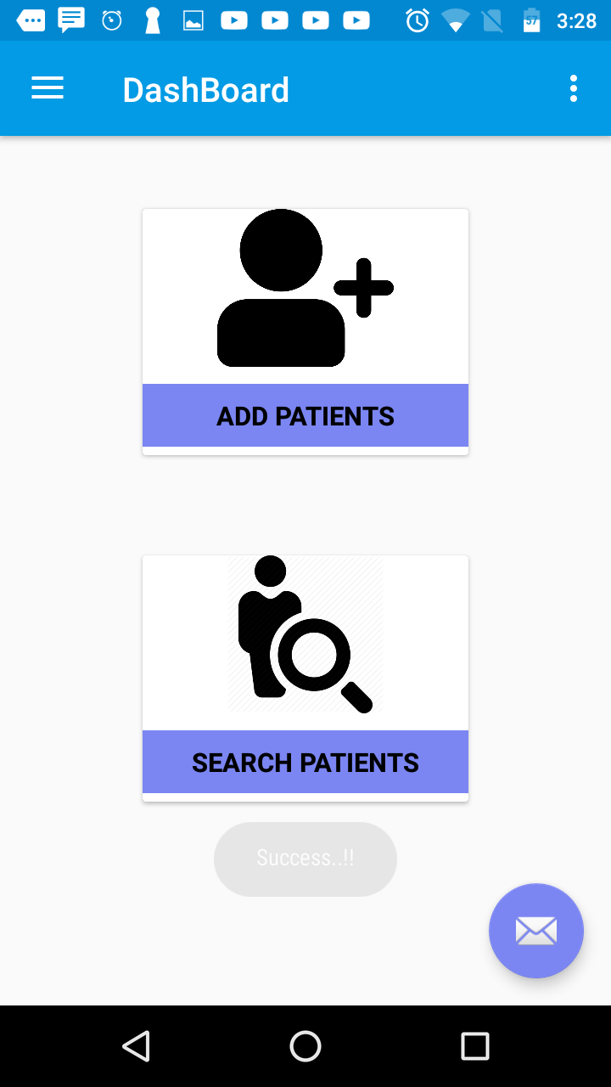

*Figure 17*

After login, Hospital can add new patient or search for patient.

Add Patient 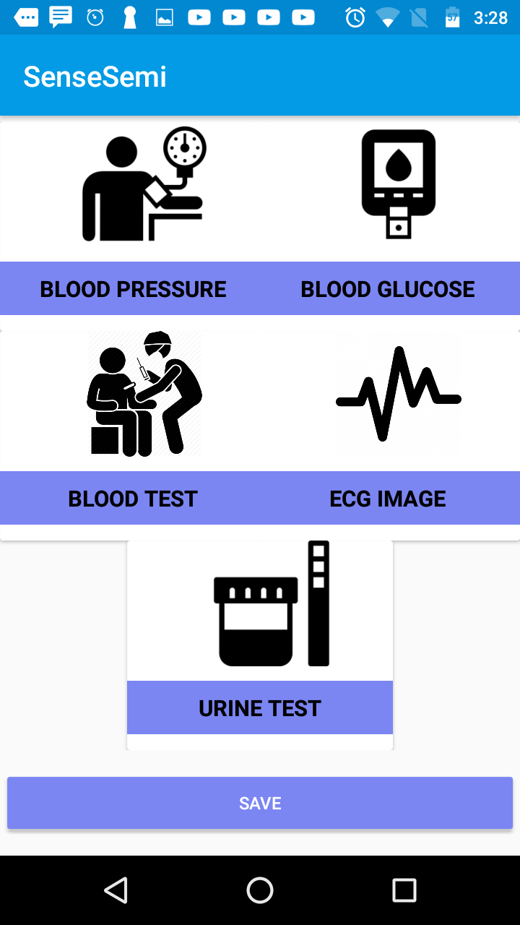

*Figure 18*

Hospital has to fill the diagnosis details

Patient Visits 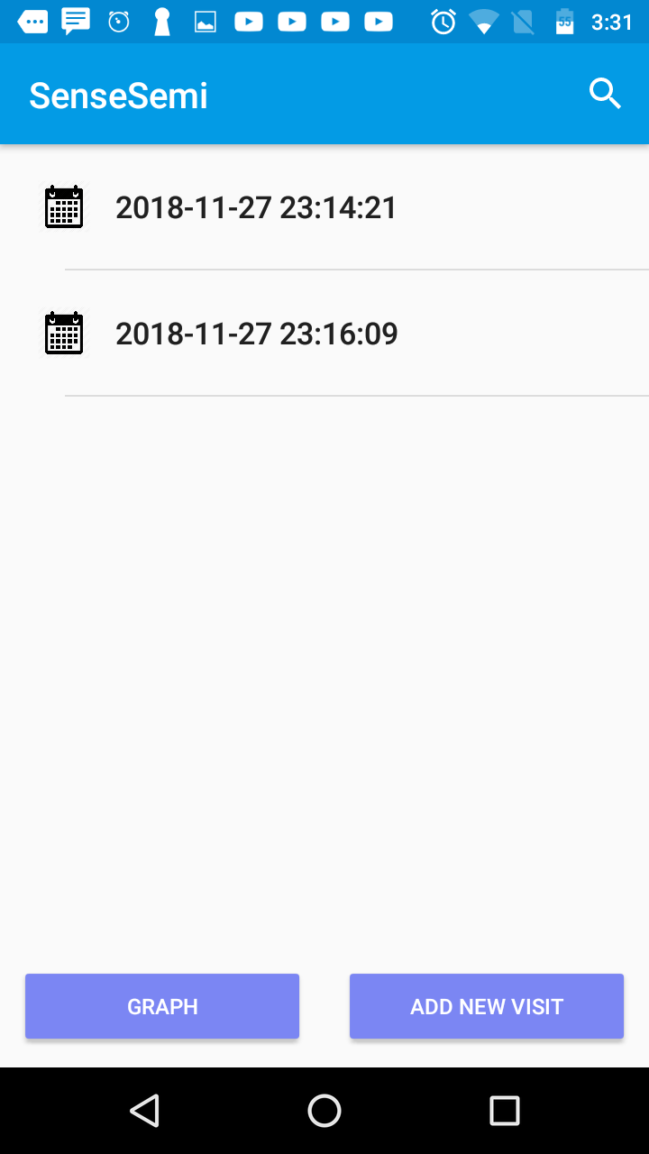

*Figure 20*

Patient visit details with dates will be displayed.

Search Patient 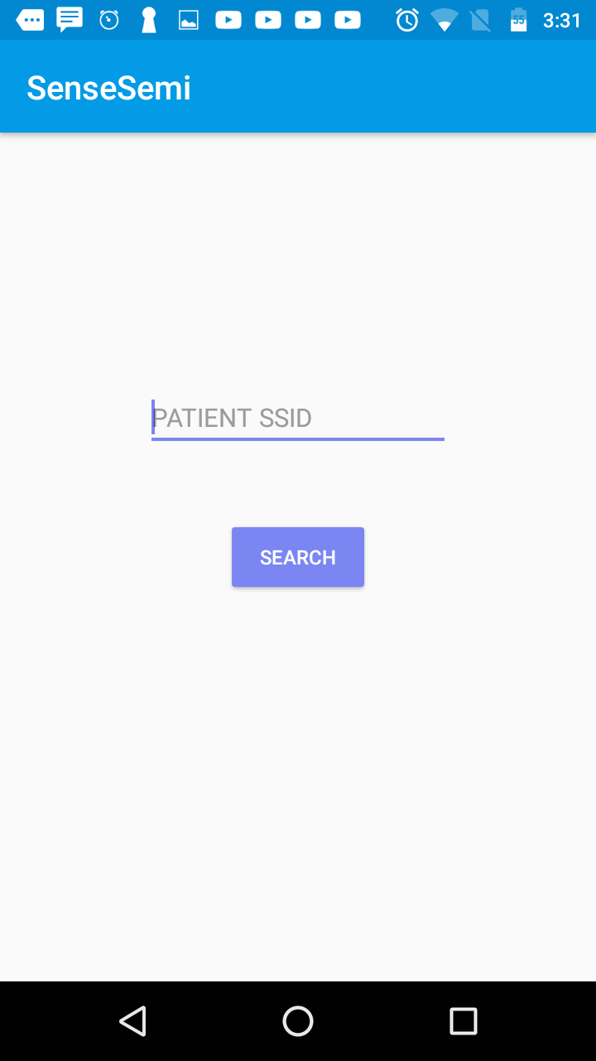

*Figure 19*

Hospital will search patient by typing in patient id.

Add New Visit *Figure 22*

If the patient visits next time, that details are entered by hospital.

View Health Graph 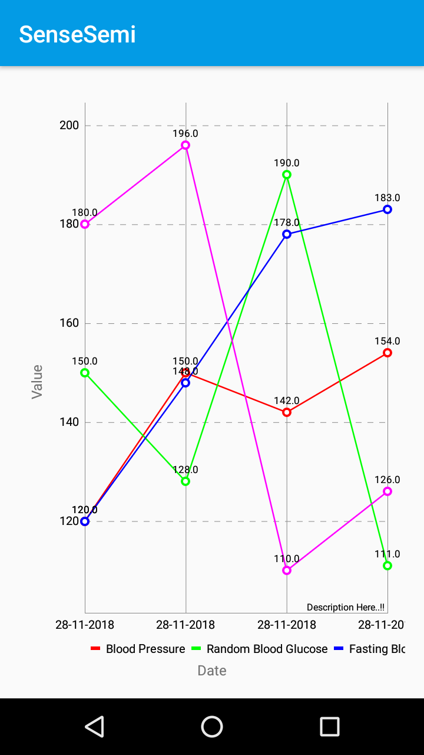*Figure 21*

Health graph will be displayed with trends in BP, BG, Body Temp etc.